Save form’s content to file using **BinaryWriter**

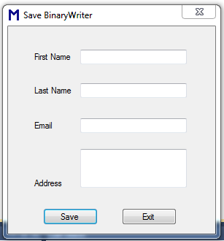

Imports System.IO

Public Class BinaryWriterClass

Private Sub btnSave_Click(ByVal sender As System.Object, ByVal e As System.EventArgs) Handles btnSave.Click

Dim myData(3) As String

myData(0) = txtFName.Text

myData(1) = txtLName.Text

myData(2) = txtEmail.Text

myData(3) = txtAddress.Text

Dim fs As FileStream = Nothing

Dim binaryWrite As BinaryWriter = Nothing

Try

fs = New FileStream("D:\BinaryData", FileMode.Append, FileAccess.Write)

binaryWrite = New BinaryWriter(fs)

For Each value As String In myData

binaryWrite.Write(value)

Next

MsgBox("Data written to binary file", MsgBoxStyle.Information, "Save")

ClearTextBox(Me)

txtFName.Select()

Catch ex As IOException

MsgBox(ex.Message, MsgBoxStyle.Critical, ex.GetType.ToString)

Finally

If binaryWrite IsNot Nothing Then

binaryWrite.Close()

End If

End Try

End Sub

Private Sub btnExit_Click(ByVal sender As System.Object, ByVal e As System.EventArgs) Handles btnExit.Click

Me.Dispose()

Me.Close()

End Sub

Public Sub ClearTextBox(ByVal f As Form)

For Each Ctl In f.Controls

If TypeOf Ctl Is TextBox Then

Ctl.Text = ""

End If

Next

End Sub

Private Sub TextGotFocus(ByVal sender As Object, ByVal e As System.EventArgs) Handles txtFName.GotFocus, txtLName.GotFocus, txtEmail.GotFocus, txtAddress.GotFocus

sender.BackColor = Color.Red

End Sub

Private Sub TextLostFocus(ByVal sender As Object, ByVal e As System.EventArgs) Handles txtFName.LostFocus, txtLName.LostFocus, txtEmail.LostFocus, txtAddress.LostFocus

sender.BackColor = Color.Pink

End Sub

Private Sub TextMouseEnter(ByVal sender As Object, ByVal e As System.EventArgs) Handles txtLName.MouseEnter, txtFName.MouseEnter, txtEmail.MouseEnter, txtAddress.MouseEnter

sender.BackColor = Color.Blue

End Sub

Private Sub TextMouseLeave(ByVal sender As Object, ByVal e As System.EventArgs) Handles txtLName.MouseLeave, txtFName.MouseLeave, txtEmail.MouseLeave, txtAddress.MouseLeave

sender.BackColor = Color.OliveDrab

End Sub

End Class